Chinook DB

Part 2

Q.1 Display Most used media types: their names and count in descending order.

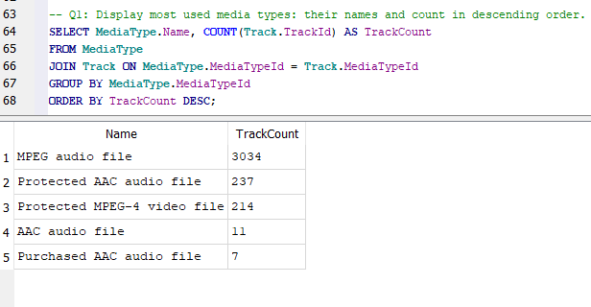

Q.2 Provide a query showing the Invoices of customers who are from Brazil. The resultant table should show the customer's full name, Invoice ID, Date of the invoice and billing country.

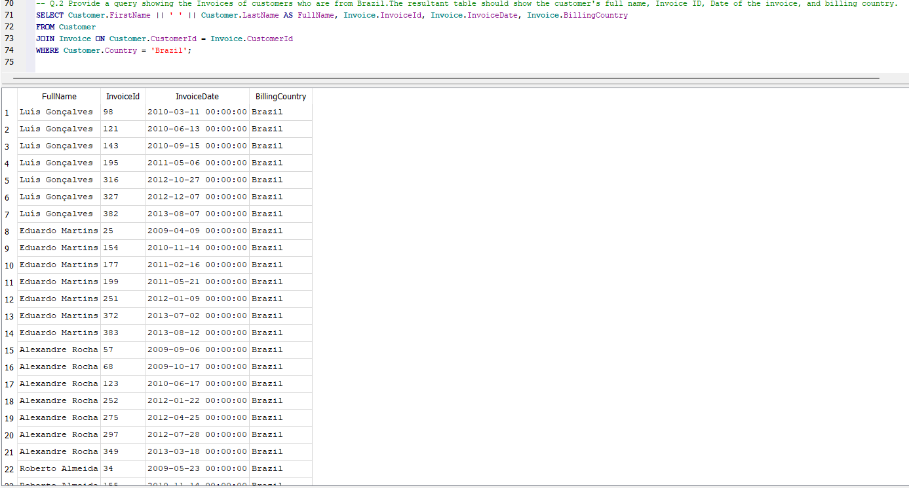

Q.3 Display artist name and total track count of the top 10 rock bands from dataset.

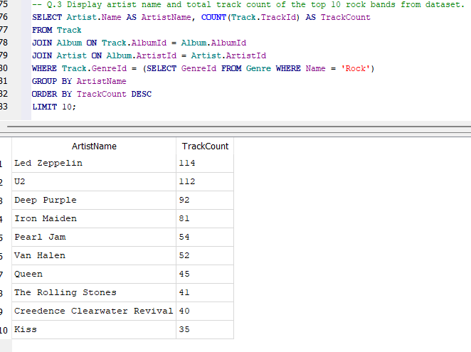

Q.4 Display the Best customer (in case of amount spent). Full name (first name and last name)

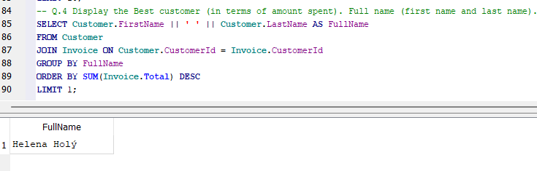

Q.5 Provide a query showing Customers (just their full names, customer ID and country) who are not in the US.

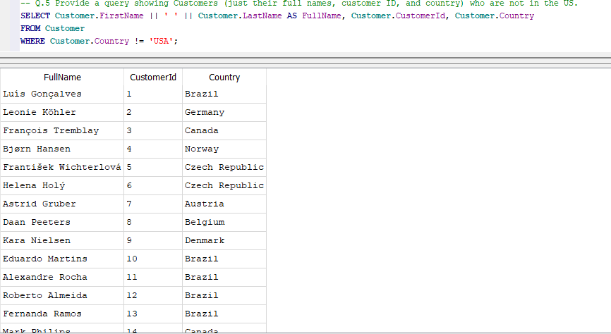

Q.6 Provide a query that shows the total number of tracks in each playlist in descending order. The Playlist name should be included on the resultant table.

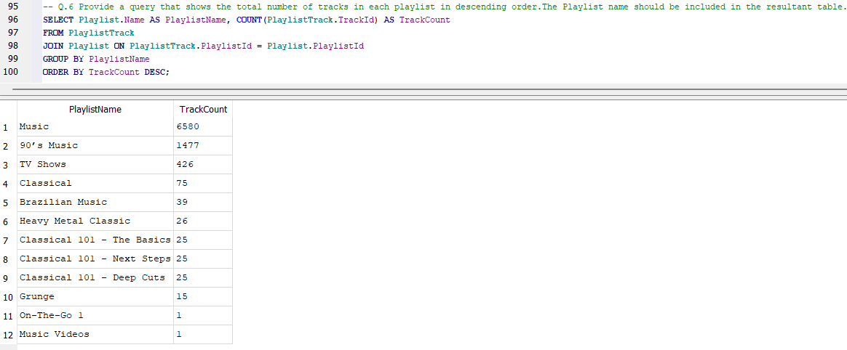

Q.7 Provide a query that shows all the Tracks, but displays no IDs. The result should include the Album name, Media type and Genre.

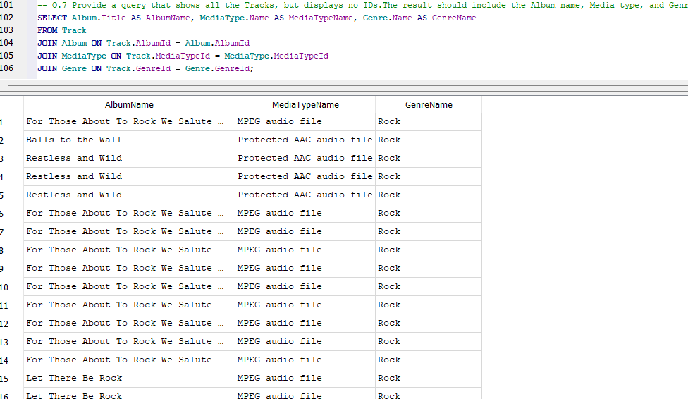

Q.8 Provide a query that shows the top 10 bestselling artists. (In terms of earning).

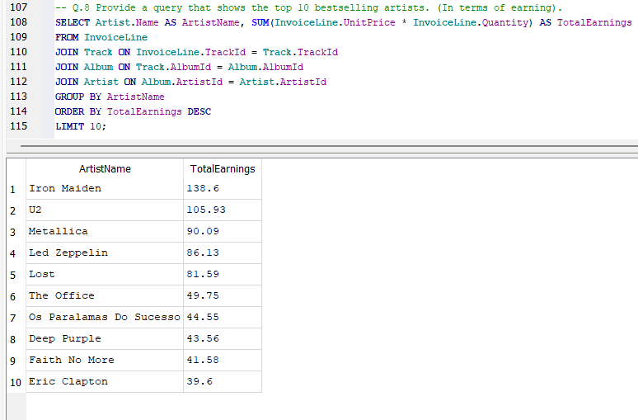

Q.9 Provide a query that shows the most purchased Media Type.

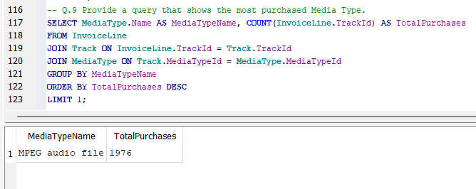

Q.10 Provide a query that shows the purchased tracks of 2013. Display Track name and Units sold.

